**Assignment : 3**

**Name : Nooras Fatima Ansari**

* **Use the Employee Details dataset and perform the following activities:**
* **Split the column CITY and separate the code associate with each city like - Allahabad[AL2] should be only Allahabad and [A2] will be separate.** ( Last 2 rows shows City name and city code )

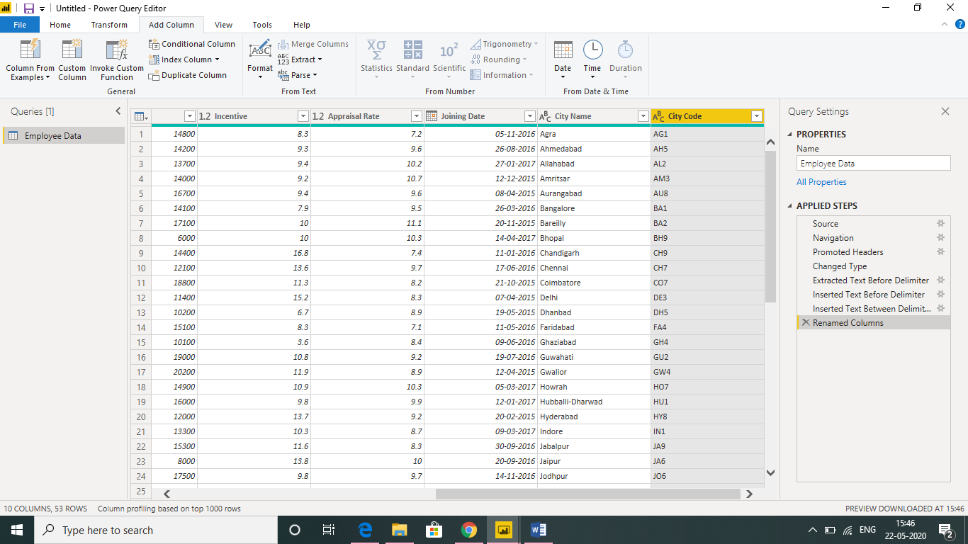

* **Extract the first name from EMPLOYEE NAME column and transform the column.** (Selected row shows employee First name)

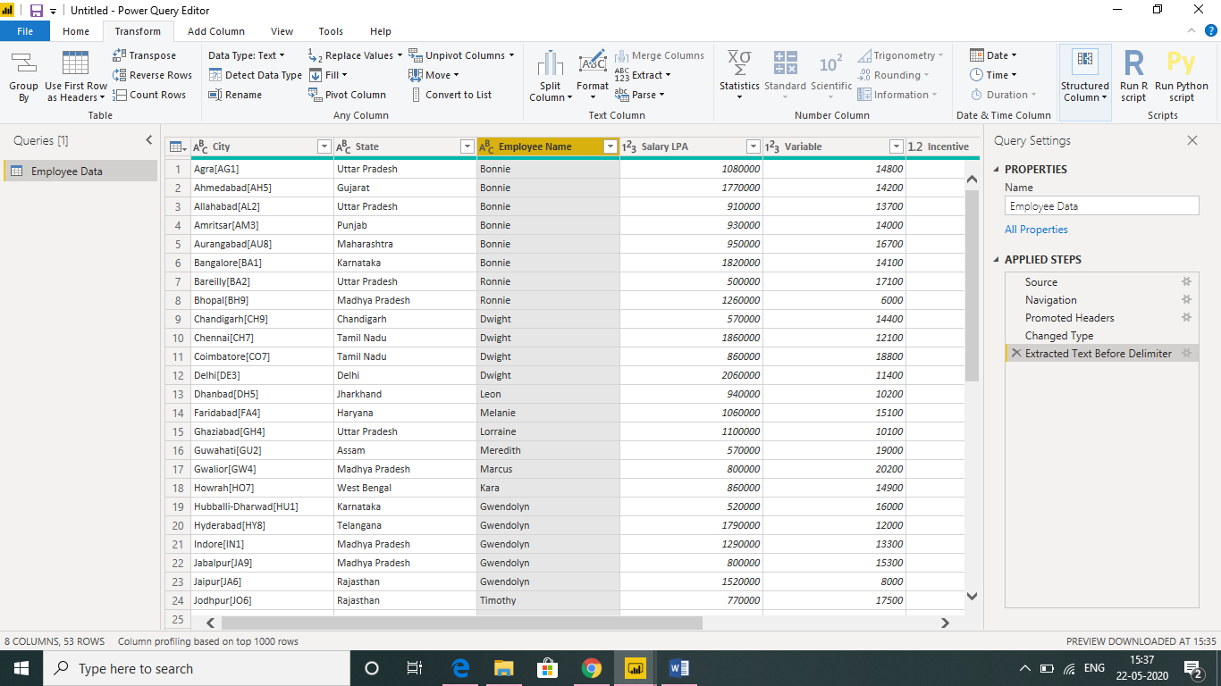

* **Using the JOINING DATE column extract the Year and no. of days for that month .** ( Last 2 rows show no of days of months and year)

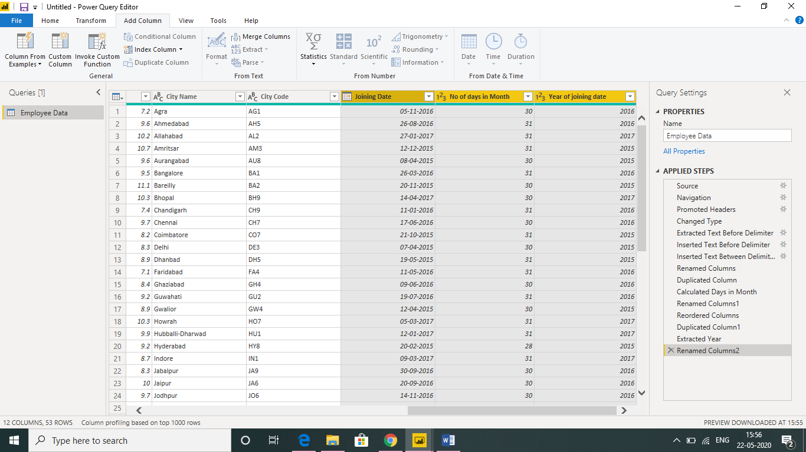

* **Create a visual of your choice and show the how much salary has been paid to each state and which state has lowest payout.**( Line and stacked column chart is used – It shows chandigarh has lowest payout. )

